This word document should be used to compliment the website that the student has created for Application Development. Content will include an introduction to the website, the purpose of the website, target audience and the display strategy for media.

Application Development

The word document to support the website created by Andrew Cooper

Andrew Cooper

1704746

Application Development

Lecturer: Kemi Ademoye

Date: 10/12/2018

Contents

1. Introduction 2

2. Application Development Concepts 2

2.1 Design Principles 2

2.1.1 Mobile First 2

2.1.2 Purpose 3

2.1.3 Colours 3

2.1.4 Navigation 3

2.2 Usability and User Experience 3

2.2.1 Usability 3

3. Requirements 3

4. Design 4

4.1 Student Web Colours 4

4.2 Student Web Purpose 4

4.3 Student Web Navigation 4

5. Implementation 4

6. Breakpoints 7

7. Conclusion 7

Bibliography 8

# Introduction

The students of University of Wales Trinity Saint David was asked to create a responsive website with a minimum of six pages that will work on a variety of web browsers and viewing platforms. The website that the student created also implement interactive functionality by using JavaScript as well as using plugins such as aos-master. The website has been tested in the web browser’s developer tools to ensure that the website is responsive and is user friendly to different media sizes such as mobile devices and large screens.

# Application Development Concepts

It is important to take development concepts into consideration when creating a website as a badly designed website can be off-putting to users. A good website should be able to engulf a user’s attention, keeping them hooked on the content what is being offered as well as stimulating the audience’s vision. [1]

To ensure that the applications created were fit for purpose the students had to research design principles, usability and user experience which would then have to be implemented into their application.

## Design Principles

Design principles can be defined as a set of rules that can assist the creator of web-based media by instructing them on areas such as layout and interactive feature design.

### 2.1.1 Mobile First

Mobile first is a method introduced by Eric Schmidt, the CEO of Google and was suggested in a talk in which he was the keynote speaker.

This concept that Schmidt has suggested simply means that the developers should create a great user experience for people using mobile devices then scaling up for larger content.

Mobile first is a pretty important concept in todays day-in-age as the growth of the mobile device market has become huge. [2] We are able to see how mobile and tablet devices are booming and how computers are becoming a less common occurrence in people’s daily routine.

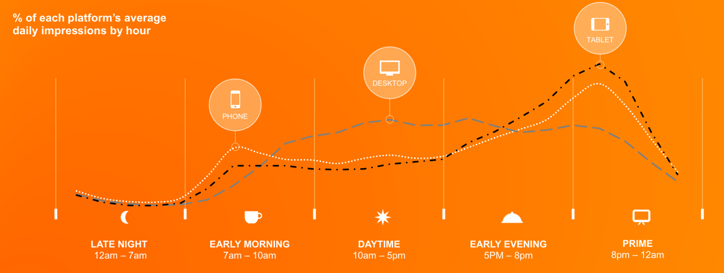

Figure 1 image obtained from https://www.smartinsights.com/mobile-marketing/mobile-marketing-analytics/mobile-marketing-statistics/

Figure 1 shows the amount of time consumers spend using mobile media and from this the student can see that an overwhelming amount of people are using a variety of devices throughout the day with a large peak of computer usage around mid-day, it is assumed this is for work use. The purpose of figure 1 is to impress that if a developer of web applications is not using the mobile first approach they may lose to competitors that have adopted this way of working.

### 2.1.2 Purpose

When developing a web-application it is a good idea to firstly have a purpose in mind, this is what the users of the application will be expecting. To meet the criteria of purpose each page on the application should have relevance to the topic and thus meet the user’s needs requirements.

### 2.1.3 Colours

Having complimentary colours on a web-application can improve a user’s overall experience on a by bringing a harmonious feeling as it will add to the page’s aesthetic appeal. The student should also aim to use text and background colours that contrast as this will improve the user’s ability to read the content on the pages. [3]

### 2.1.4 Navigation

Navigation refers to how easy it is for the user to move around the website, should the user struggle to navigate with ease. Navigation links should be short but descriptive, the user should know exactly where they are going to end up.

## Usability and User Experience

Usability and user experience can further be broken up into two section. But to summarise the both it is ensuring that the user enjoys using the product as well as the ease of use.

### Usability

For a webpage to be deemed as usable the following four aspects should be taken into consideration:

* Functionality
* Learnability
* Flexibility
* Industry design

# Requirements

The student has created a website using html, css, JavaScript as well as other plugins such as aos-master. The purpose of the website is to advertise “Skinny’s Ukulele Store” which is a fictitious store imagined for this assignment. The target audience for this website is anyone who wishes to either purchase a new ukulele or to start lesson. Each page has relevance as the pages are all ukulele based, whether it be purchasing a ukulele or finding lessons. Other content includes ukulele maintenance and a “about us” page to give some background information about the people who are running the website/ conducting lessons. The last page on the website is a “Contact Us” page which has been put in place to allow people to voice their opinions. This is a good feature as it gives a sense of customer relation.

# Design

The design in which the student has adopted for this assignment was mobile first. This allowed him to make a web-application that looked good for mobile devices then scale up for larger devices as suggested by Eric Schmidt. [2]

## 4.1 Student Web Colours

The user of the web-application will notice that there is a large proportion of white space. This has been done to give a sense of a modern, more spacious and uncluttered website. [3] Also the use of black text on a white background means that reading content on the page should be easy and a lesser risk to eye strain.

## 4.2 Student Web Purpose

The web-application has also been created with purpose thought through, the website has been created with six pages that although cover different aspects of information, they all come together to become relevant pages.

## 4.3 Student Web Navigation

The student has also ensured that navigation throughout the website is easy by having a nav bar on each page. On the home page the user will also find many different buttons and image links that will get them to the place that they wish to be within the website. An example of this is on the “Come see our latest stock” images (figure 2). Each of these images will redirect the user store page.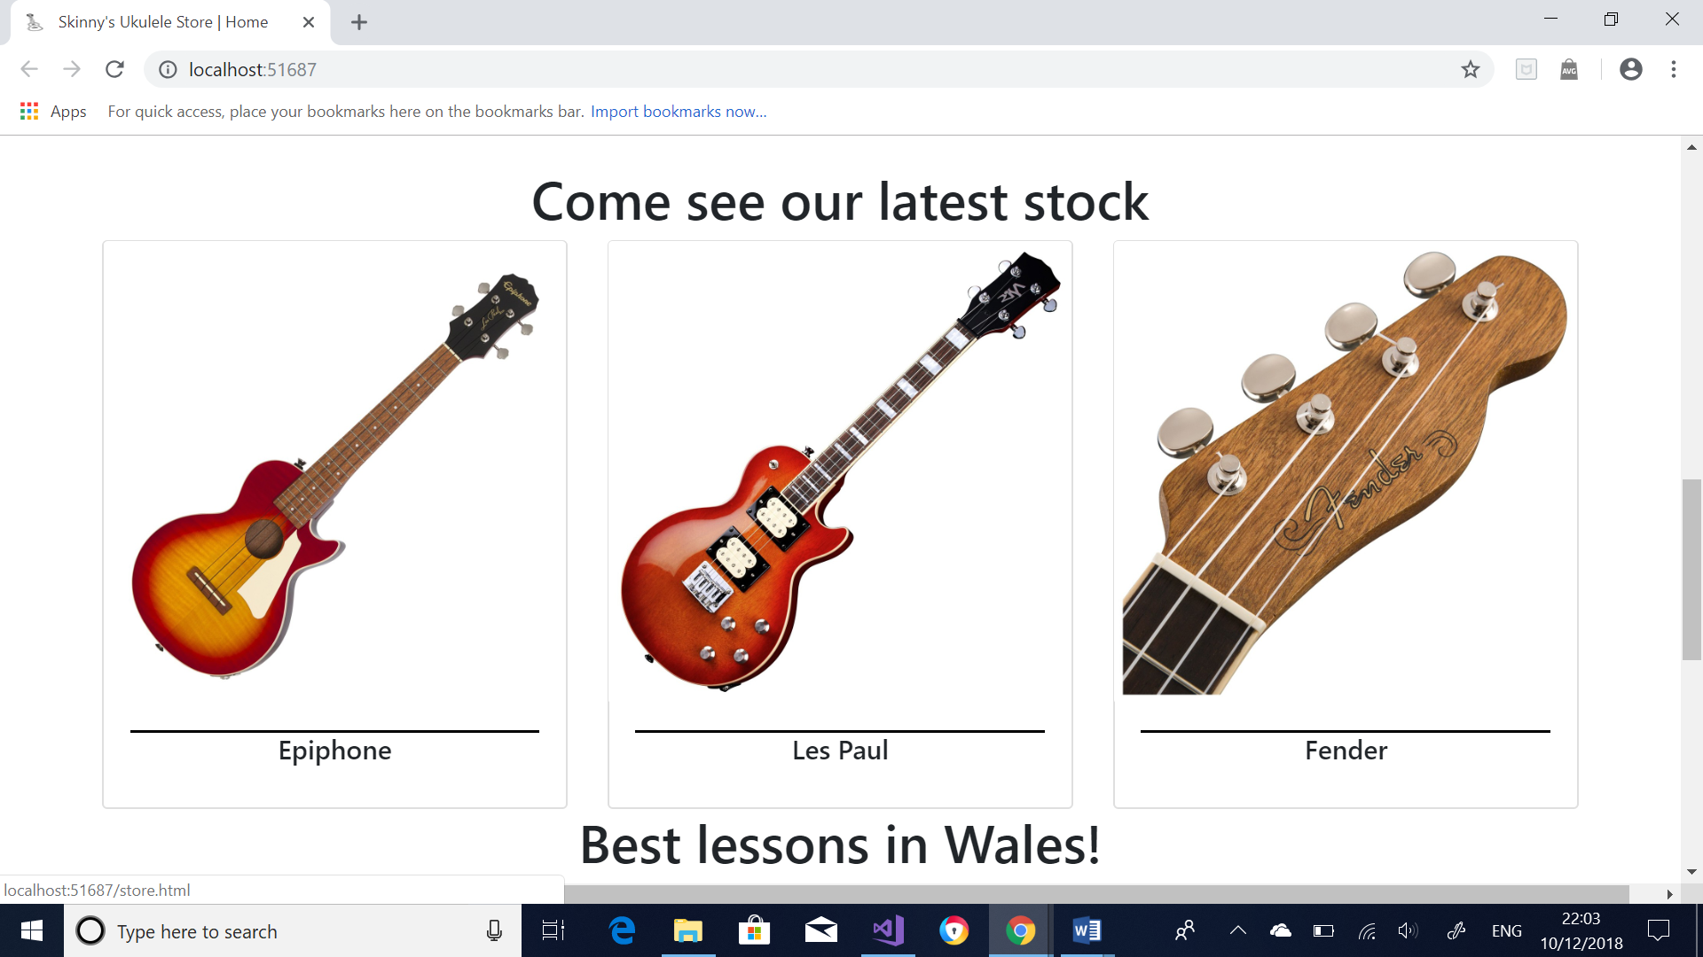

Figure

# Implementation

To add functionality to the web-application the student has implemented JavaScript as well as plugins to add extra interest to the pages.

The first feature that has been added is done with the plugin “aos-master”, which can be seen on the home page. Firstly, when scrolling down the page a ukulele will fade in from the left hand side of the screen seen in figure 3.

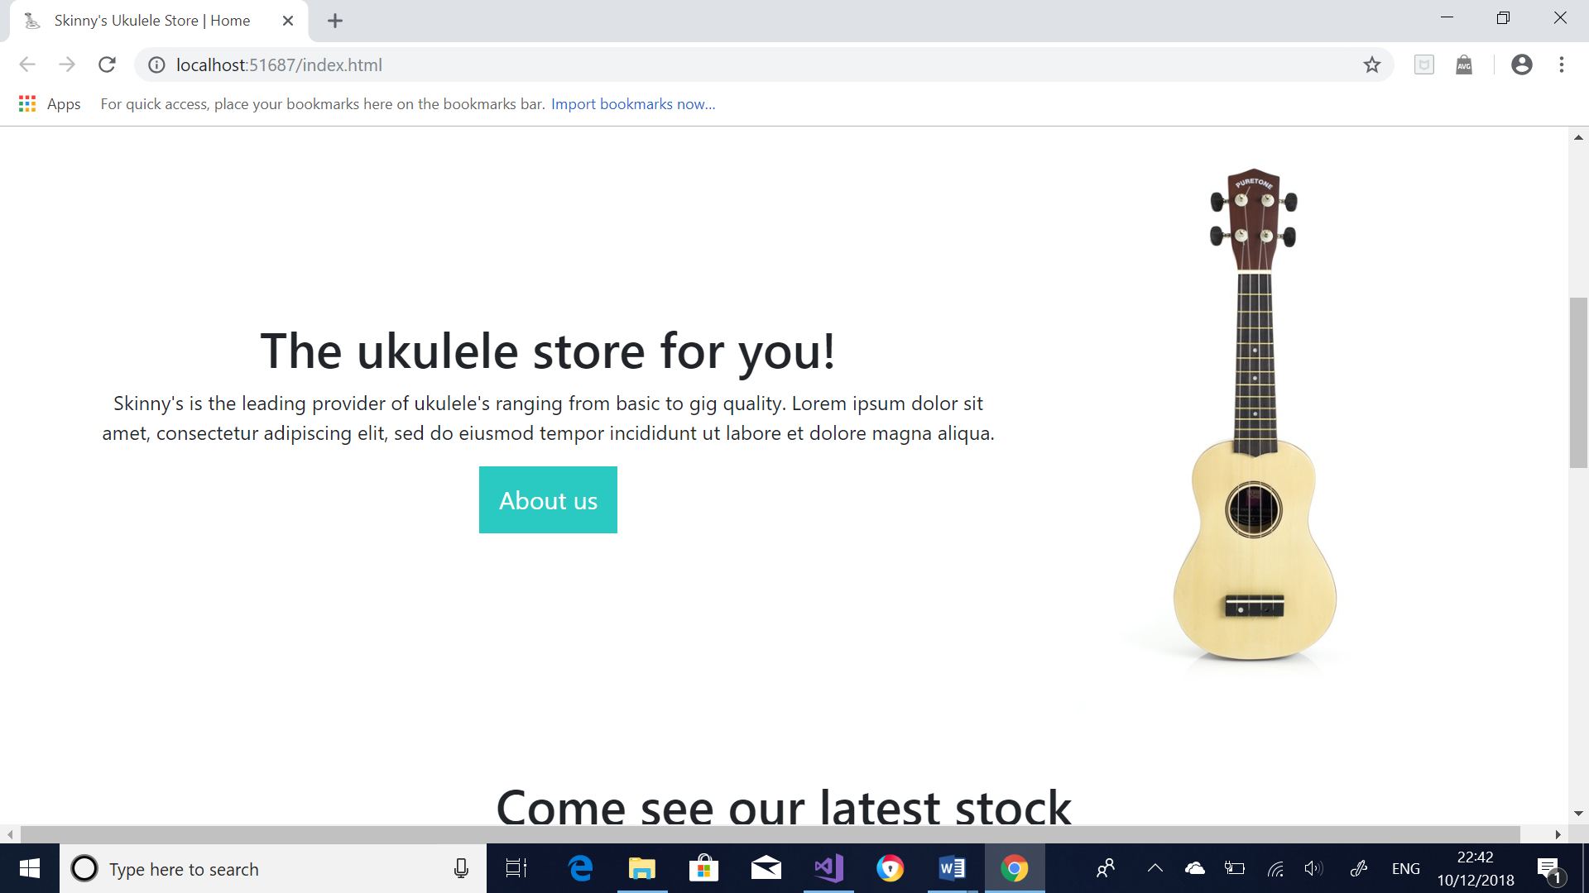

Figure

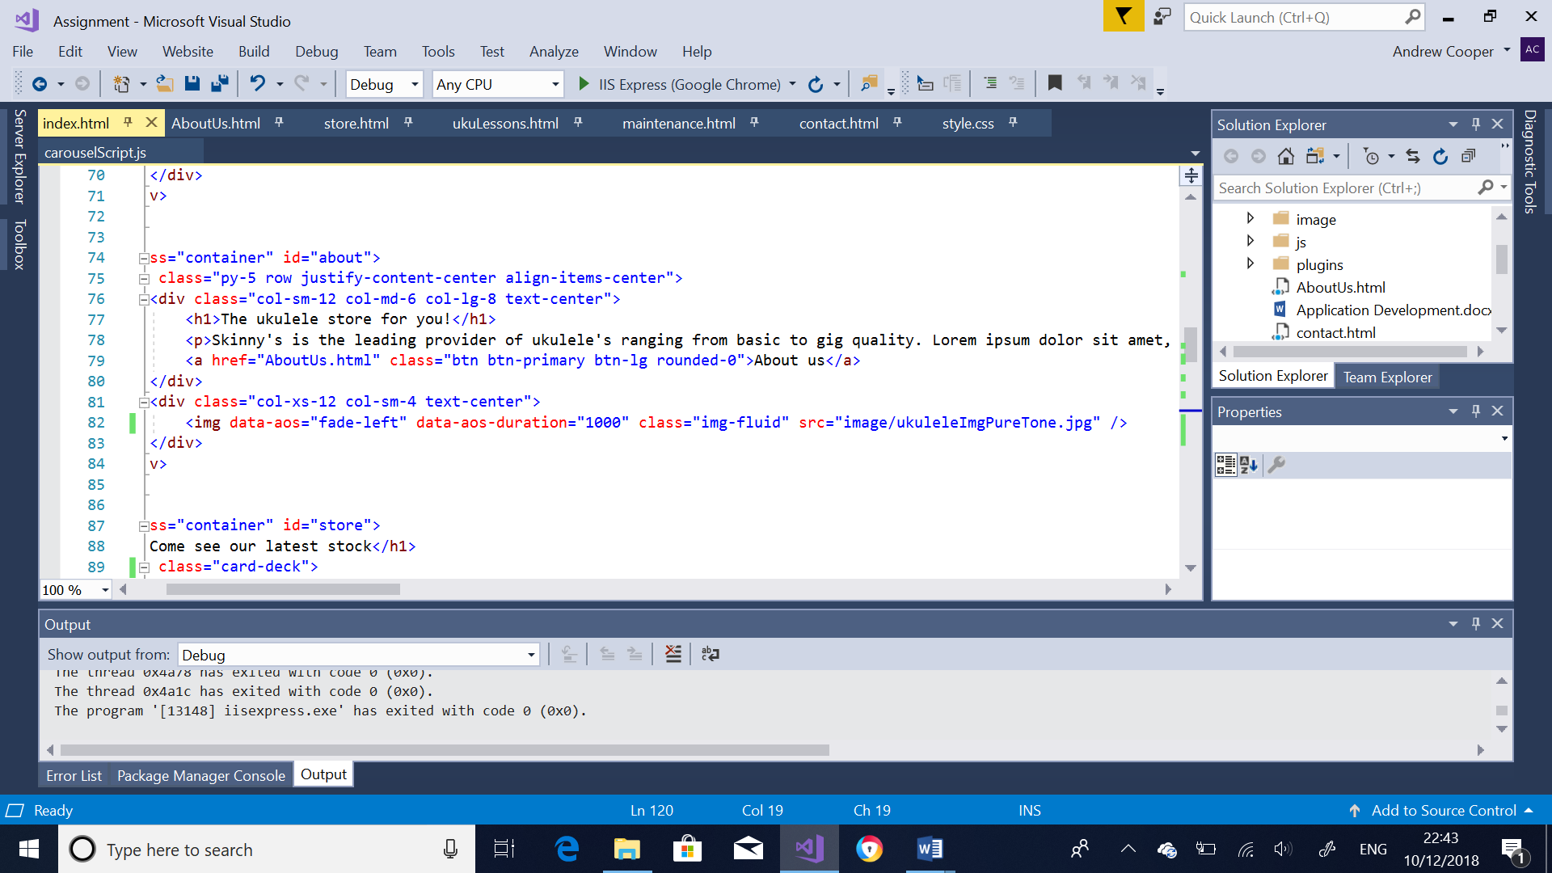

Figure

Figure 4 shows the code that the student has included in his code for this to work. This code will run for 1 second before it is complete.

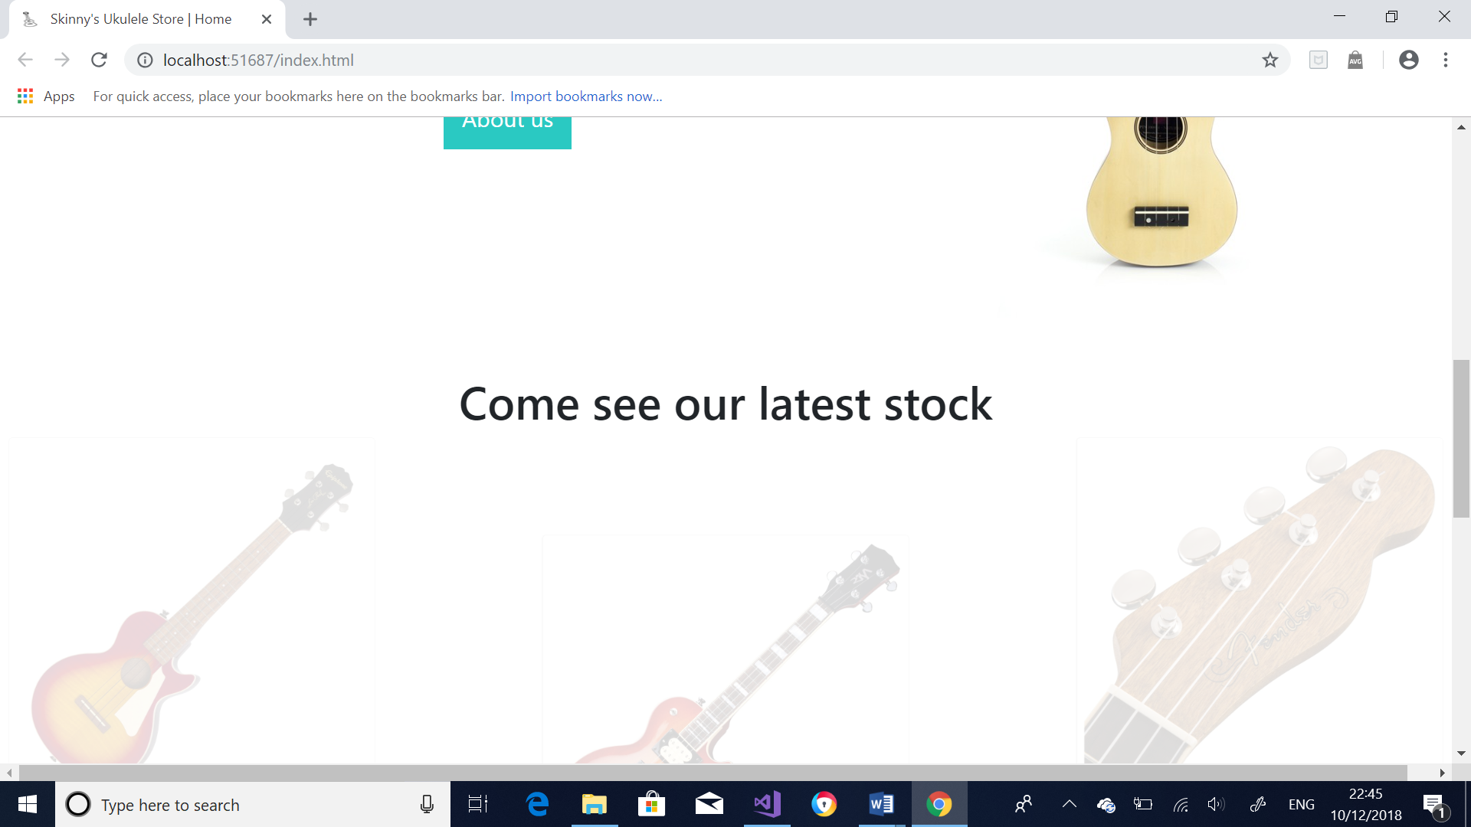

Figure

Figure 5 uses the same code but had the different images coming from different areas (right, left and up) to eventually meet in the middle.

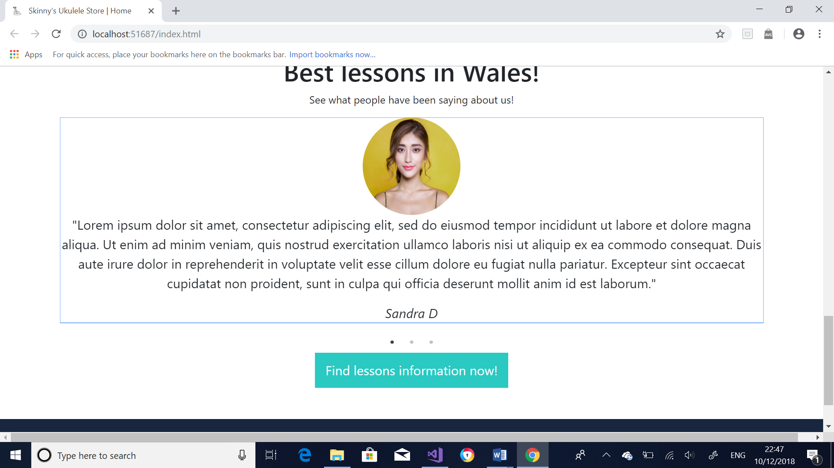

Figure

Figure 6 shows the testimonial section within the student’s web-application. It is a carousel that has been created with Slick-1.8.1 plugin. It has been implemented with this plugin because it is fully responsive and scales with its container. Also, it is swipe enabled meaning that users using touch screen devices can swipe left or right [4] to see the next part of the slide show.

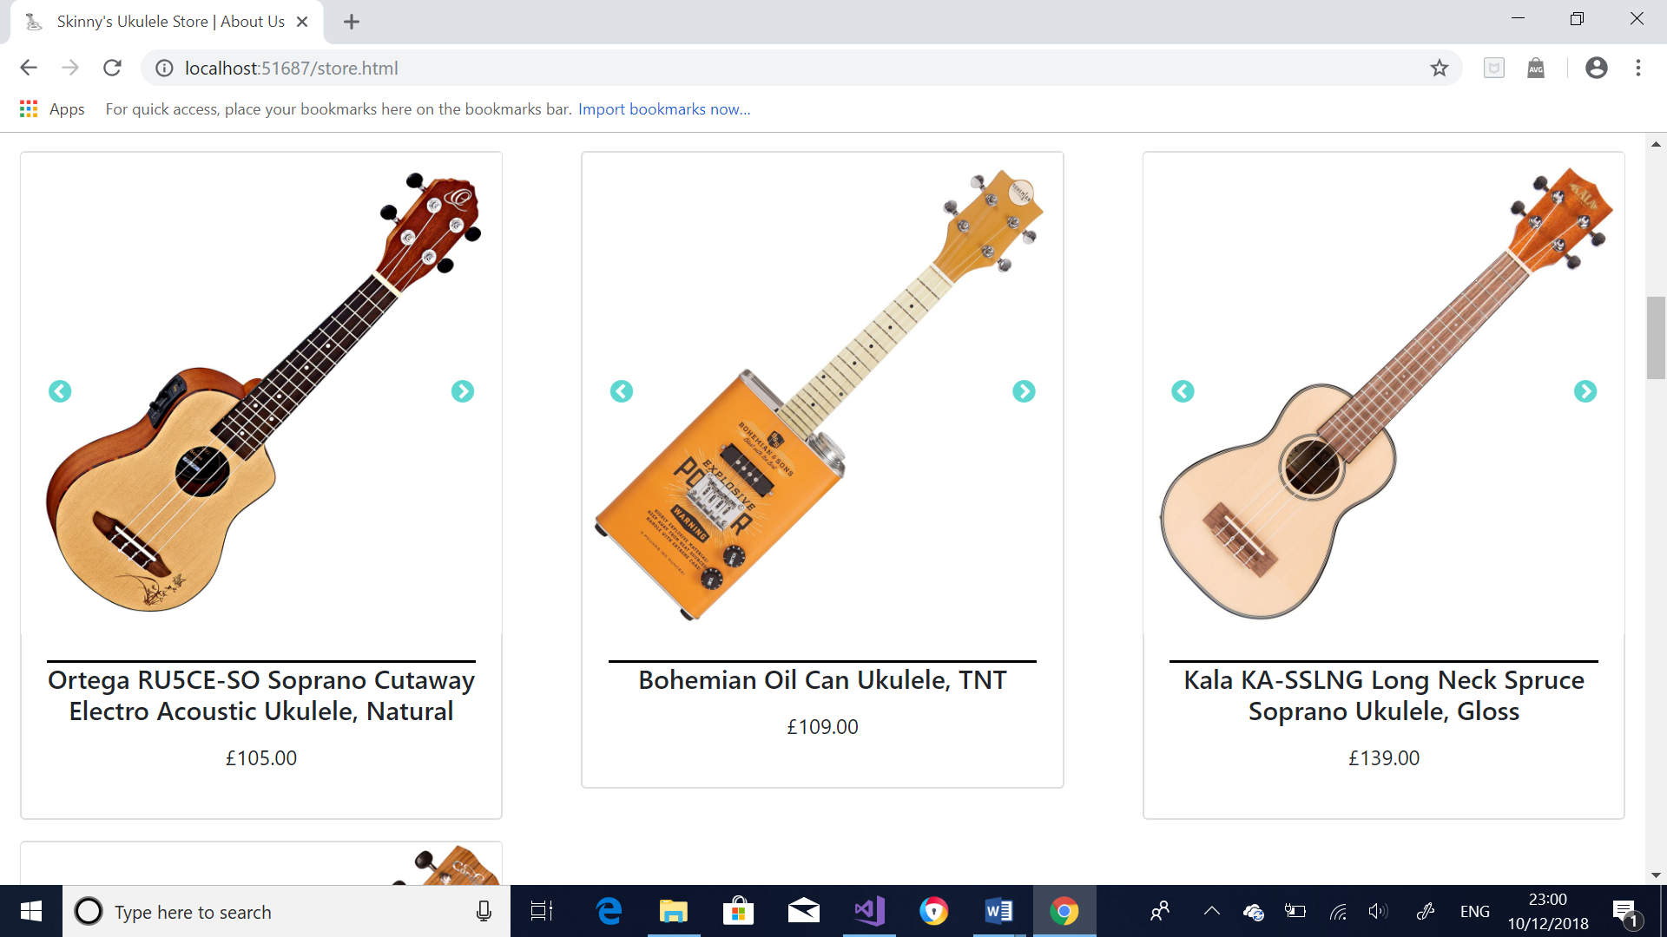

Figure

The images taken from the store page, captured in figure 7 shows that the user on the website can scroll through images of the ukulele. This is an important feature as it allows users to see exactly what they will be receiving.

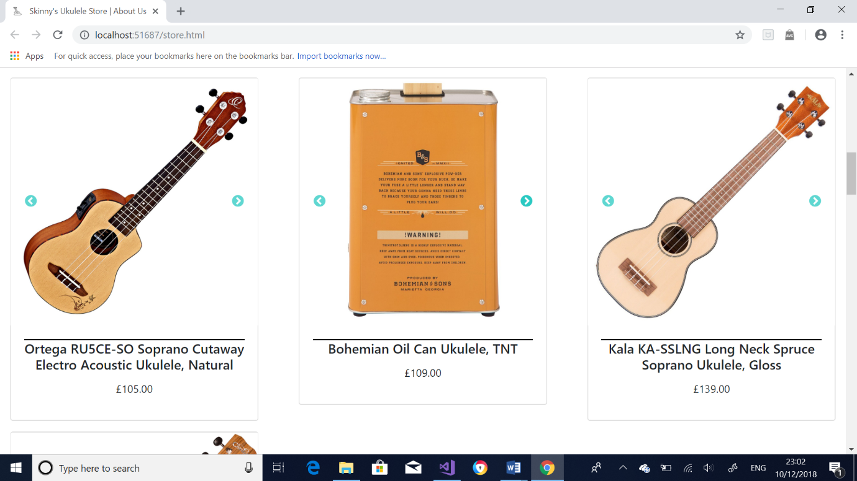 Figure 8 shows another view of the ukulele, demonstrating that the carousel feature is in good working condition.

Figure

# 6. Breakpoints

A breakpoint in a web-application is used to ensure that the end user gets the best possible layout for the device they are viewing the content on. Examples of this is ensuring that a user using a mobile device will never have to scroll horizontally to view content as this is very bad practice and not very professional. The two main methods of ensuring that the website is responsive is by either adding media queries or by using bootstraps version. The student has utilized the bootstrap’s way of making a web-application responsive.

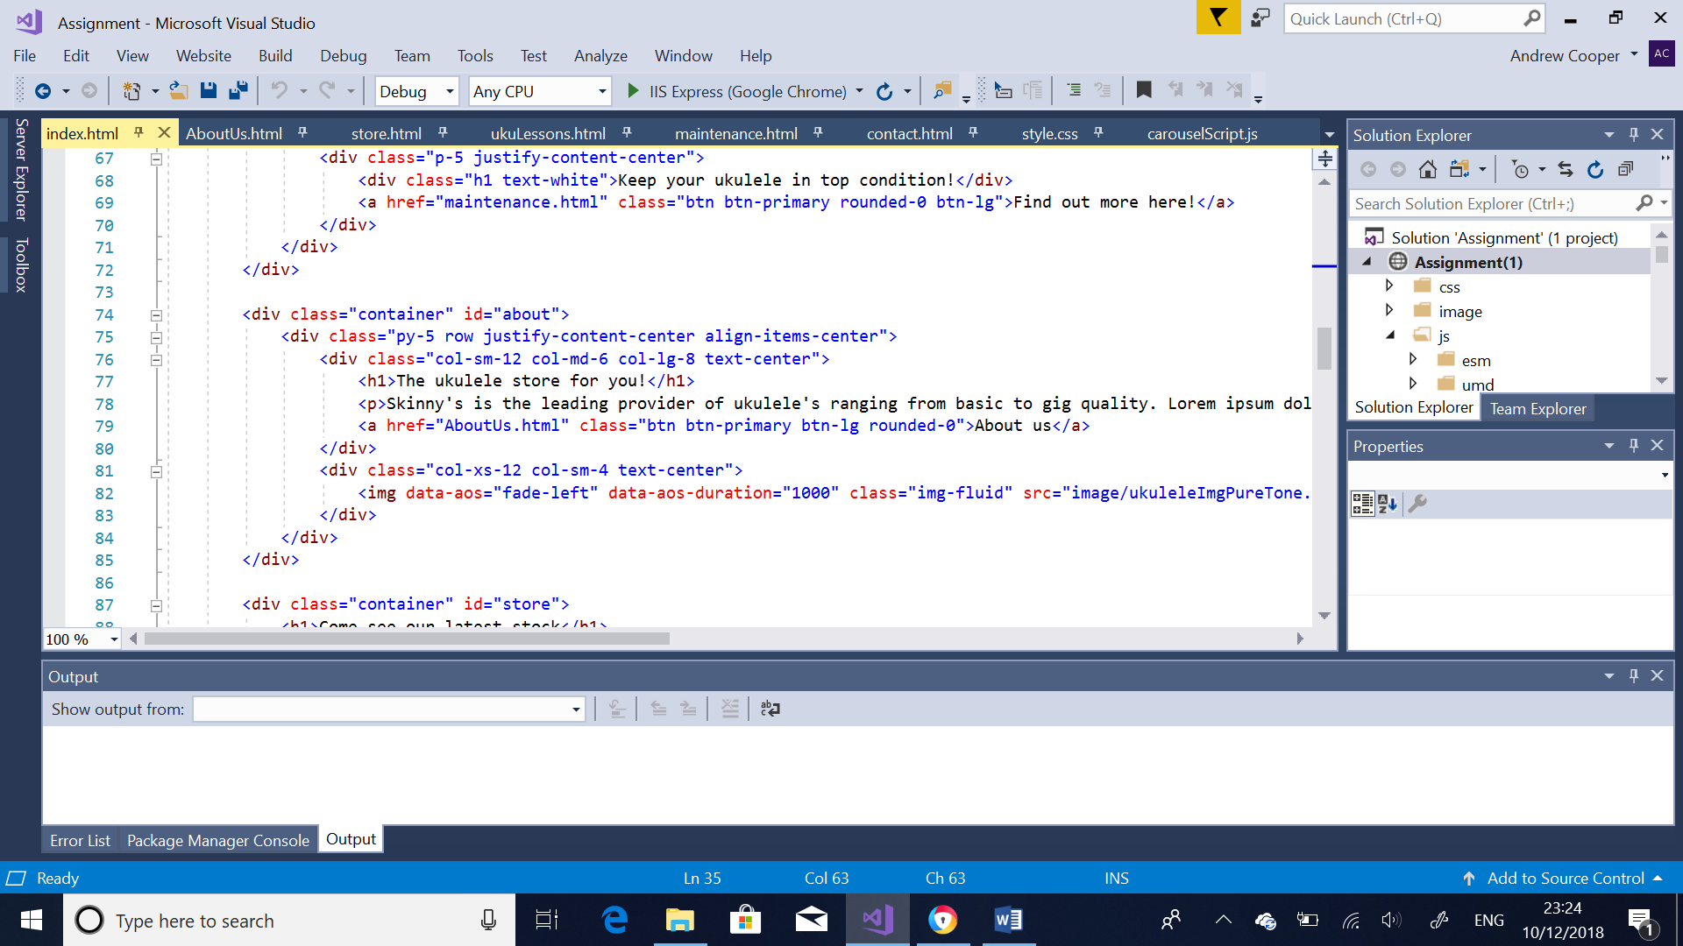

Figure

Figure 9 displays the working code used in the web-application created by the student. It states that if the user is using a small device, span 12 columns, a medium device will use 6 columns and a large device will use 8 columns. This method of creating a responsive web-application can be seen throughout the code.

# 7. Conclusion

The student was asked to create a responsive web-application that is interactive and fit for use. The student has researched application development concepts and created a ukulele store and advertisement website for his fictional company “Skinny’s Ukulele Store” and included JavaScript and plugins to make the website interactive by implementing carousels and image transitions. The website that has been created is also responsive to an acceptable level which he did so by using the bootstrap screen sizes.

# Bibliography

|  |  |
| --- | --- |
| [1] | A. Osmani, “JavaScript,” *The Voice of Web Design,* no. 313, p. 24, 2018. |
| [2] | M. Hamblen, “Google CEO preaches 'mobile first',” Computerworld, 12 Feburary 2010. [Online]. Available: https://www.computerworld.com/article/2520954/mobile-wireless/google-ceo-preaches--mobile-first-.html. [Accessed 1 12 2018]. |
| [3] | S. Woods, “10 TOP PRINCIPLES OF EFFECTIVE WEB DESIGN,” ShortieDesigns, 04 March 2014. [Online]. Available: https://shortiedesigns.com/2014/03/10-top-principles-effective-web-design/. [Accessed 01 12 2018]. |
| [4] | UNKNOWN, “TechTerms,” 21 June 2012. [Online]. Available: https://techterms.com/definition/swipe. [Accessed 4 12 2018]. |